CSE 3024 – WEB MINING LAB
L – 33.34
DHRUBANKA DUTTA – 17BCE1019
TOPIC : VSM AND K MEANS
FACULTY : SRIDHAR R

You are given 9 one-line documents here. Consider the following keywords to represent the
documents in the vector space model:
[1] Automotive [2] Car [3] motorcycles [4] self-drive [5] IoT [6] hire [7] Dhoni
Represent the documents in vector space Model using these keywords and use it as input to cluster the
documents using Manhattan distance as parameter. Ignore case differences.
You also need to do K- means clustering with K=4.
Documents for use in question
Doc1
Electric automotive maker Tesla Inc. is likely to introduce its products in India sometime in the summer of 2017.
Doc 2
Automotive major Mahindra likely to introduce driverless cars
Doc 3
BMW plans to introduce its own motorcycles in india
Doc 4
Just drive, a self-drive car rental firm uses smart vehicle technology based on IoT
Doc 5
Automotive industry going to hire thousands in 2018
Doc 6
Famous cricket player Dhoni brought his priced car Hummer which is an SUV
Doc 7
Dhoni led india to its second world cup victory
Doc 8
IoT in cars will lead to more safety and make driverless vehicle revolution possible
Doc 9
Sachin recommended Dhoni for the indian skipper post

CODE:

## Initialisation

import pandas as pd
import numpy as np
import matplotlib.pyplot as plt

# VSM PART

doc1 = 'electric automotive motor tesla inc. is likely to introduce its product in india sometime in the summer of 2017'
doc2 = 'automotive major mahindra likely to introduce driverless cars'
doc3 = 'bmw plans to introduce its own motorcycle in india'
doc4 = 'just drive, a self-drive car rental firm uses smart vehicle technology based on iot'
doc5 = 'automotive industry going to hire thousands in 2018'
doc6 = 'famous cricket player dhoni brought his priced car hummer which is an suv'
doc7 = 'dhoni led india to it second world cup victory'
doc8 = 'iot in cars will lead to more safety and make driverless vehicle revolution possible'
doc9 = 'sachin recommended dhoni for indian skipper post'

k1 = 'automotive'
k2 = 'car'
k3 = 'motorcycles'
k4 = 'self-drive'
k5 = 'iot'
k6 = 'hire'
k7 = 'dhoni'

#initialize vector space matrix
vsm = [[0 for x in range(7)]for y in range(9)]

#obtain tokens from documents
doc1 = doc1.split(' ')
doc2 = doc2.split(' ')
doc3 = doc3.split(' ')
doc4 = doc4.split(' ')
doc5 = doc5.split(' ')
doc6 = doc6.split(' ')
doc7 = doc7.split(' ')
doc8 = doc8.split(' ')
doc9 = doc9.split(' ')

docs = [] # Form document matrix
docs.append(doc1)
docs.append(doc2)
docs.append(doc3)
docs.append(doc4)
docs.append(doc5)
docs.append(doc6)
docs.append(doc7)
docs.append(doc8)
docs.append(doc9)

terms = [] # Form terms matrix
terms.append(k1)
terms.append(k2)
terms.append(k3)
terms.append(k4)
terms.append(k5)
terms.append(k6)
terms.append(k7)

print('\nDOCUMENT TOKENS\n') #lists of document tokens
for doc in docs:
print(doc)

print('\nTERMS TOKENS\n') #lists of terms tokens
for term in terms:
print(term)

for i in range(9): # traverse every document token list
for j in range(7): # search for all terms in that document
if terms[j] in docs[i]: # if a certain term is found in that document
vsm[i][j] = docs[i].count(terms[j]) # add the count of the term to the matrix under that document and term indices

print('\nVECTOR SPACE MATRIX\n') # display vector space matrix
for i in range(9):
print (vsm[i])

dsm = [[0 for x in range(9)]for y in range(9)] #initialize document similarity matrix for similarity between docs

def sim(i,j,matrix): # fucntion to calculate distances between documents
dist = 0
for k in range(7):
dist+=(matrix[i][k]*matrix[j][k])
return dist

# enter values in dsm
for i in range(9):
for j in range(9):
dsm[i][j] = sim(i,j,vsm)
dsm[j][i] = sim(i,j,vsm)

print("\nDOCUMENT SIMILARITY MATRIX\n")
for i in range(9):
print(dsm[i])

# dictionary for pandas and matplotlib
df = {
'x': [],
'y': []
}

# store x and y values of documents in dictionary
for i in range(9):
for j in range(9):
if dsm[i][j]!=0:
df['x'].append(i)
df['y'].append(j)

print(df)

# K-MEANS PART

df = pd.DataFrame(df)
print(df)

np.random.seed(200)
k = 4
# centroids[i] = [x, y]
centroids = {
i+1: [np.random.randint(0, 80), np.random.randint(0, 80)]
for i in range(k)
}

fig = plt.figure(figsize=(5, 5))
plt.scatter(df['x'], df['y'], color='k')
colmap = {1: 'r', 2: 'g', 3: 'b'}
for i in centroids.keys():
plt.scatter(*centroids[i], color=colmap[i])
plt.xlim(0, 80)
plt.ylim(0, 80)
plt.show()

## Assignment Stage

def assignment(df, centroids):
for i in centroids.keys():
# sqrt((x1 - x2)^2 - (y1 - y2)^2)
df['distance_from_{}'.format(i)] = (
np.sqrt(
(df['x'] - centroids[i][0]) ** 2
+ (df['y'] - centroids[i][1]) ** 2
)
)
centroid_distance_cols = ['distance_from_{}'.format(i) for i in centroids.keys()]
df['closest'] = df.loc[:, centroid_distance_cols].idxmin(axis=1)
df['closest'] = df['closest'].map(lambda x: int(x.lstrip('distance_from_')))
df['color'] = df['closest'].map(lambda x: colmap[x])
return df

df = assignment(df, centroids)
print(df.head())

fig = plt.figure(figsize=(5, 5))
plt.scatter(df['x'], df['y'], color=df['color'], alpha=0.5, edgecolor='k')
for i in centroids.keys():
plt.scatter(*centroids[i], color=colmap[i])
plt.xlim(0, 80)
plt.ylim(0, 80)
plt.show()

## Update Stage

import copy

old_centroids = copy.deepcopy(centroids)

def update(k):
for i in centroids.keys():
centroids[i][0] = np.mean(df[df['closest'] == i]['x'])
centroids[i][1] = np.mean(df[df['closest'] == i]['y'])
return k

centroids = update(centroids)

fig = plt.figure(figsize=(5, 5))
ax = plt.axes()
plt.scatter(df['x'], df['y'], color=df['color'], alpha=0.5, edgecolor='k')
for i in centroids.keys():
plt.scatter(*centroids[i], color=colmap[i])
plt.xlim(0, 80)
plt.ylim(0, 80)
for i in old_centroids.keys():
old_x = old_centroids[i][0]
old_y = old_centroids[i][1]
dx = (centroids[i][0] - old_centroids[i][0]) * 0.75
dy = (centroids[i][1] - old_centroids[i][1]) * 0.75
ax.arrow(old_x, old_y, dx, dy, head_width=2, head_length=3, fc=colmap[i], ec=colmap[i])
plt.show()

## Repeat Assigment Stage

df = assignment(df, centroids)

# Plot results
fig = plt.figure(figsize=(5, 5))
plt.scatter(df['x'], df['y'], color=df['color'], alpha=0.5, edgecolor='k')
for i in centroids.keys():
plt.scatter(*centroids[i], color=colmap[i])
plt.xlim(0, 80)
plt.ylim(0, 80)
plt.show()

# Continue until all assigned categories don't change any more
while True:
closest_centroids = df['closest'].copy(deep=True)
centroids = update(centroids)
df = assignment(df, centroids)
if closest_centroids.equals(df['closest']):
break

fig = plt.figure(figsize=(5, 5))
plt.scatter(df['x'], df['y'], color=df['color'], alpha=0.5, edgecolor='k')
for i in centroids.keys():
plt.scatter(*centroids[i], color=colmap[i])
plt.xlim(0, 80)
plt.ylim(0, 80)
plt.show()

OUTPUT :

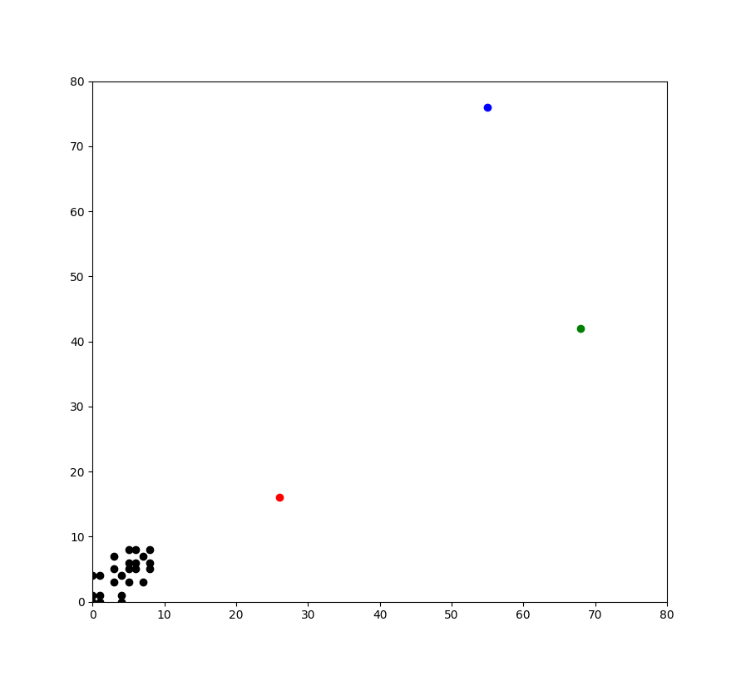
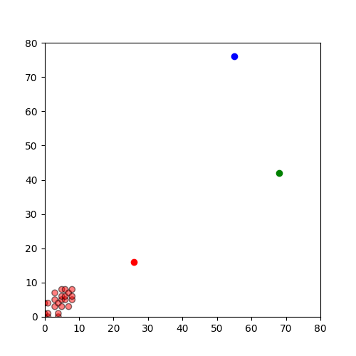

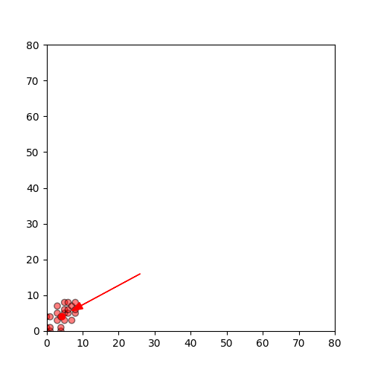
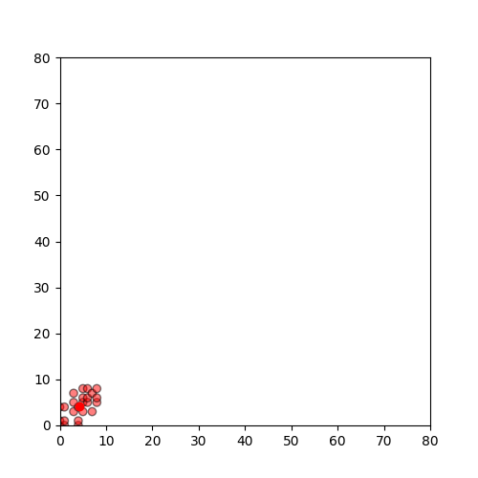

last two figures are same. Hence stop.

Part B
Use the same program which you have developed for part A to do “ K-means clustering” of the following web documents means
with K=4. Use the keywords.
[1] Tesla [2] Electric [3] Car/Vehicle/Automobile [4] pollution [5] de-monetisation [6] GST [7] black money

Download the webpage into a .txt file [ ignore images,tables and limit the size of the document to 500 words Max] and build your vector space model using Term frequency.
Ignore case differences. Treat singular and plural of nouns as same. Treat Car/vehicle/automobile as one word [synonyms]. Treat “black money” as a single word.
List of webpages:
[1] https://www.zigwheels.com/newcars/Tesla
[2] https://www.financialexpress.com/auto/car-news/mahindra-to-launch-indias-first-electric-suv-in-2019-all-new-e-verito-sedan-on-cards/1266853/
[3] https://en.wikipedia.org/wiki/Toyota_Prius
[4] https://economictimes.indiatimes.com/industry/auto/auto-news/government-plans-new-policy-to-promote-electric-vehicles/articleshow/65237123.cms
[5] https://indianexpress.com/article/india/india-news-india/demonetisation-hits-electric-vehicles-industry-society-of-manufacturers-of-electric-vehicles-4395104/
[6] https://www.livemint.com/Politics/ySbMKTIC4MINsz1btccBJO/How-demonetisation-affected-the-Indian-economy-in-10-charts.html
[7] https://www.hrblock.in/blog/impact-gst-automobile-industry-2/
[8] https://inc42.com/buzz/electric-vehicles-this-week-centre-reduces-gst-on-lithium-ion-batteries-hyundai-to-launch-electric-suv-in-india-and-more/
[9] https://www.youthkiawaaz.com/2017/12/impact-of-demonetisation-on-the-indian-economy/
[10] https://indianexpress.com/article/india/demonetisation-effects-cash-crisis-mobile-wallets-internet-banking-4406005/
[11] https://www.news18.com/news/business/how-gst-will-curb-tax-evasion-1446035.html
[12] https://economictimes.indiatimes.com/small-biz/policy-trends/is-gst-helping-the-indian-economy-for-the-better/articleshow/65319874.cms

CODE:

## Initialisation

import pandas as pd
import numpy as np
import matplotlib.pyplot as plt

# VSM PART

f1 = open("partb1.txt",'r')
f2 = open("partb2.txt",'r')
f3 = open("partb3.txt",'r')
f4 = open("partb4.txt",'r')
f5 = open("partb5.txt",'r')
f6 = open("partb6.txt",'r')
f7 = open("partb7.txt",'r')
f8 = open("partb8.txt",'r')
f9 = open("partb9.txt",'r')
f10 = open("partb10.txt",'r')
f11 = open("partb11.txt",'r')
f12 = open("partb12.txt",'r')

k1 = 'Tesla'
k2 = 'electric'
k3 = 'car'
k4 = 'vehicle'
k5 = 'automobile'
k6 = 'pollution'
k7 = 'de-monetisation'
k8 = 'GST'
k9 = 'black money'

#initialize vector space matrix
vsm = [[0 for x in range(10)]for y in range(9)]

#get contents of docs
doc1 = f1.read()
doc2 = f2.read()
doc3 = f3.read()
doc4 = f4.read()
doc5 = f5.read()
doc6 = f6.read()
doc7 = f7.read()
doc8 = f8.read()
doc9 = f9.read()
doc10 = f10.read()
doc11 = f11.read()
doc12 = f12.read()

#obtain tokens from documents
doc1 = doc1.split(' ')
doc2 = doc2.split(' ')
doc3 = doc3.split(' ')
doc4 = doc4.split(' ')
doc5 = doc5.split(' ')
doc6 = doc6.split(' ')
doc7 = doc7.split(' ')
doc8 = doc8.split(' ')
doc9 = doc9.split(' ')
doc10 = doc10.split(' ')
doc11 = doc11.split(' ')
doc12 = doc12.split(' ')

docs = [] # Form document matrix
docs.append(doc1)
docs.append(doc2)
docs.append(doc3)
docs.append(doc4)
docs.append(doc5)
docs.append(doc6)
docs.append(doc7)
docs.append(doc8)
docs.append(doc9)
docs.append(doc10)
docs.append(doc11)
docs.append(doc12)

terms = [] # Form terms matrix
terms.append(k1)
terms.append(k2)
terms.append(k3)
terms.append(k4)
terms.append(k5)
terms.append(k6)
terms.append(k7)
terms.append(k8)
terms.append(k9)

print('\nDOCUMENT TOKENS\n') #lists of document tokens
for doc in docs:
print(doc)

print('\nTERMS TOKENS\n') #lists of terms tokens
for term in terms:
print(term)

for i in range(12): # traverse every document token list
for j in range(9): # search for all terms in that document
if terms[j] in docs[i]: # if a certain term is found in that document
vsm[i][j] = docs[i].count(terms[j]) # add the count of the term to the matrix under that document and term indices

print('\nVECTOR SPACE MATRIX\n') # display vector space matrix
for i in range(12):
print (vsm[i])

dsm = [[0 for x in range(12)]for y in range(12)] #initialize document similarity matrix for similarity between docs

def sim(i,j,matrix): # fucntion to calculate distances between documents
dist = 0
for k in range(9):
dist+=(matrix[i][k]*matrix[j][k])
return dist

# enter values in dsm
for i in range(12):
for j in range(12):
dsm[i][j] = sim(i,j,vsm)
dsm[j][i] = sim(i,j,vsm)

print("\nDOCUMENT SIMILARITY MATRIX\n")
for i in range(12):
print(dsm[i])

# dictionary for pandas and matplotlib
df = {
'x': [],
'y': []
}

# store x and y values of documents in dictionary
for i in range(12):
for j in range(12):
if dsm[i][j]!=0:
df['x'].append(i)
df['y'].append(j)

print(df)

# K-MEANS PART

df = pd.DataFrame(df)
print(df)

np.random.seed(200)
k = 3
# centroids[i] = [x, y]
centroids = {
i+1: [np.random.randint(0, 80), np.random.randint(0, 80)]
for i in range(k)
}

fig = plt.figure(figsize=(5, 5))
plt.scatter(df['x'], df['y'], color='k')
colmap = {1: 'r', 2: 'g', 3: 'b'}
for i in centroids.keys():
plt.scatter(*centroids[i], color=colmap[i])
plt.xlim(0, 80)
plt.ylim(0, 80)
plt.show()

## Assignment Stage

def assignment(df, centroids):
for i in centroids.keys():
# sqrt((x1 - x2)^2 - (y1 - y2)^2)
df['distance_from_{}'.format(i)] = (
np.sqrt(
(df['x'] - centroids[i][0]) ** 2
+ (df['y'] - centroids[i][1]) ** 2
)
)
centroid_distance_cols = ['distance_from_{}'.format(i) for i in centroids.keys()]
df['closest'] = df.loc[:, centroid_distance_cols].idxmin(axis=1)
df['closest'] = df['closest'].map(lambda x: int(x.lstrip('distance_from_')))
df['color'] = df['closest'].map(lambda x: colmap[x])
return df

df = assignment(df, centroids)
print(df.head())

fig = plt.figure(figsize=(5, 5))
plt.scatter(df['x'], df['y'], color=df['color'], alpha=0.5, edgecolor='k')
for i in centroids.keys():
plt.scatter(*centroids[i], color=colmap[i])
plt.xlim(0, 80)
plt.ylim(0, 80)
plt.show()

## Update Stage

import copy

old_centroids = copy.deepcopy(centroids)

def update(k):
for i in centroids.keys():
centroids[i][0] = np.mean(df[df['closest'] == i]['x'])
centroids[i][1] = np.mean(df[df['closest'] == i]['y'])
return k

centroids = update(centroids)

fig = plt.figure(figsize=(5, 5))
ax = plt.axes()
plt.scatter(df['x'], df['y'], color=df['color'], alpha=0.5, edgecolor='k')
for i in centroids.keys():
plt.scatter(*centroids[i], color=colmap[i])
plt.xlim(0, 80)
plt.ylim(0, 80)
for i in old_centroids.keys():
old_x = old_centroids[i][0]
old_y = old_centroids[i][1]
dx = (centroids[i][0] - old_centroids[i][0]) * 0.75
dy = (centroids[i][1] - old_centroids[i][1]) * 0.75
ax.arrow(old_x, old_y, dx, dy, head_width=2, head_length=3, fc=colmap[i], ec=colmap[i])
plt.show()

## Repeat Assigment Stage

df = assignment(df, centroids)

# Plot results
fig = plt.figure(figsize=(5, 5))
plt.scatter(df['x'], df['y'], color=df['color'], alpha=0.5, edgecolor='k')
for i in centroids.keys():
plt.scatter(*centroids[i], color=colmap[i])
plt.xlim(0, 80)
plt.ylim(0, 80)
plt.show()

# Continue until all assigned categories don't change any more
while True:
closest_centroids = df['closest'].copy(deep=True)
centroids = update(centroids)
df = assignment(df, centroids)
if closest_centroids.equals(df['closest']):
break

fig = plt.figure(figsize=(5, 5))
plt.scatter(df['x'], df['y'], color=df['color'], alpha=0.5, edgecolor='k')
for i in centroids.keys():
plt.scatter(*centroids[i], color=colmap[i])
plt.xlim(0, 80)
plt.ylim(0, 80)
plt.show()

f1.close()
f2.close()
f3.close()
f4.close()
f5.close()
f6.close()
f7.close()
f8.close()
f9.close()
f10.close()
f11.close()
f12.close()

OUTPUT:
